Data Preprocessing
Before performing data analysis and visualization, the dataset was preprocessed to improve its quality, consistency, and usability. The following preprocessing steps were carried out:

1. State Name Standardization
- Standardized abbreviated and inconsistent state names into their official names to maintain uniformity across the dataset.
- Examples:
  - MP → Madhya Pradesh
  - Pondy → Puducherry
  - Jammu&Kashmir → Jammu & Kashmir

2. Latitude and Longitude Formatting
- Formatted all latitude and longitude values to four decimal places to ensure consistent geographic precision and improve readability while maintaining sufficient accuracy for state-level analysis.

3. Usage Value Formatting
- Formatted the Usage column to two decimal places to maintain numerical consistency and improve the readability of electricity consumption values throughout the dataset.

4. Conversion of Dataset into an Excel Table
- Converted the raw dataset into an Excel Table using Excel's table feature.
- This enhanced data organization and enabled efficient sorting, filtering, structured referencing, and easier data management during analysis.

5. Duplicate Record Verification
- Checked the dataset for duplicate records and removed redundant entries wherever necessary to improve data quality and eliminate repetitive records.

6. Missing Value Verification
- Examined the dataset for missing or null values and confirmed that all essential fields contained valid and complete information.

7. Date Format Validation
- Verified that all date values followed a consistent format throughout the dataset, ensuring accurate chronological analysis and visualization.

8. Data Type Validation
- Confirmed that all numerical attributes, including Usage, Latitude, and Longitude, were stored in numeric format, while the Date field was stored in the appropriate date format.

9. Data Consistency Check
- Reviewed the dataset to ensure consistency in state names, regional classifications, and geographical information across all records.

10. Final Data Validation
- Performed a final quality check to verify that the dataset was clean, accurate, well-structured, and ready for visualization and analysis in Tableau.
Business Questions with Visualizations

1. How did electricity consumption change before, during, and after the COVID-19 lockdown?

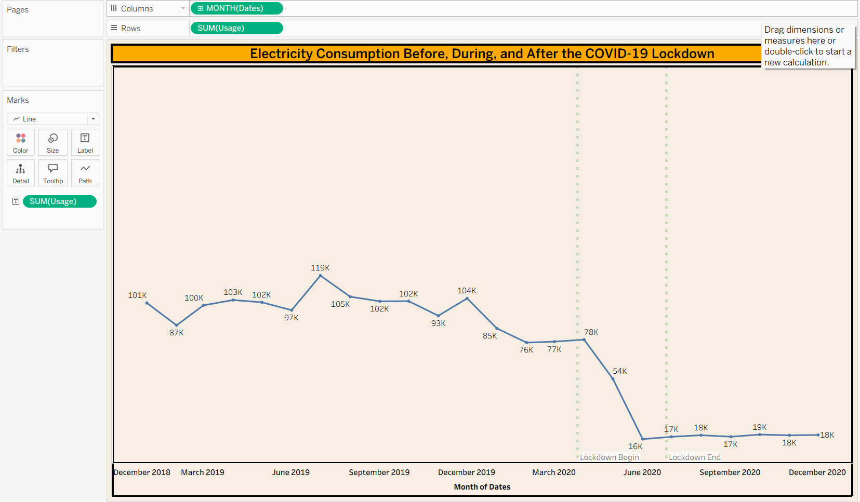

2. How does electricity consumption in 2020 compare with the corresponding months in 2019?

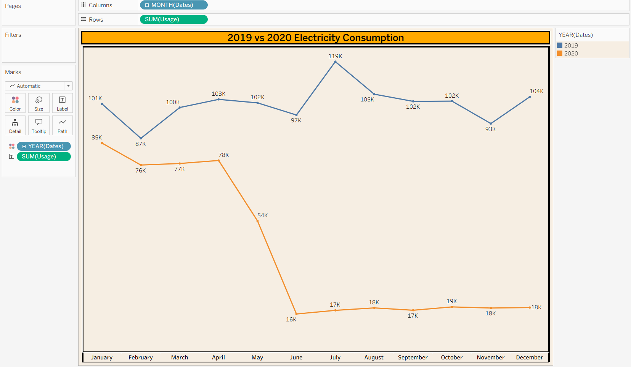

3.Which Indian states recorded the highest and lowest electricity consumption?

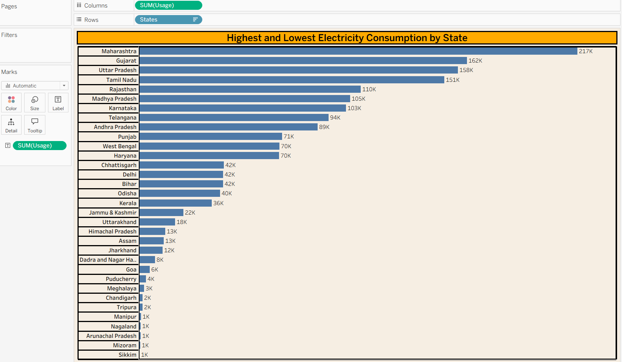

4. How did electricity consumption vary across different states of India?

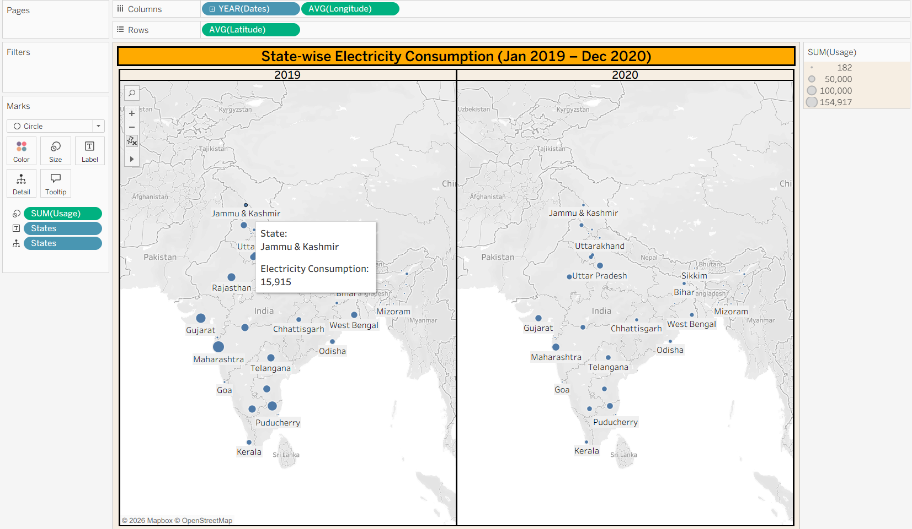

5.Which regions consumed more electricity: North, South, East, West, or North East?
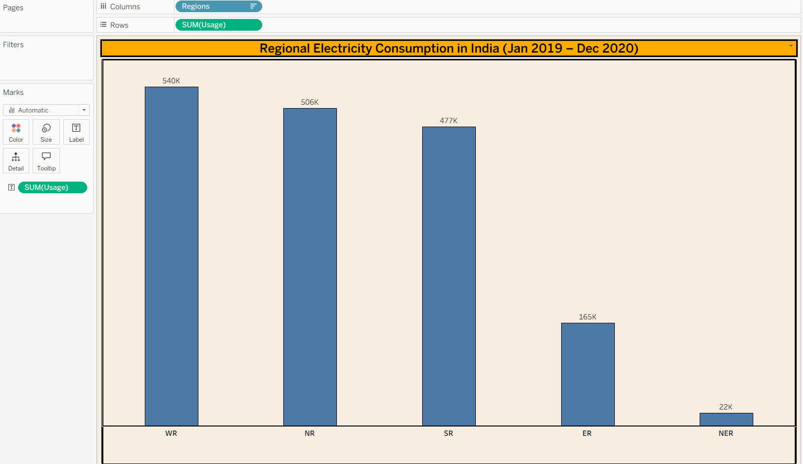

6. Which five states contributed the highest share of total electricity consumption?
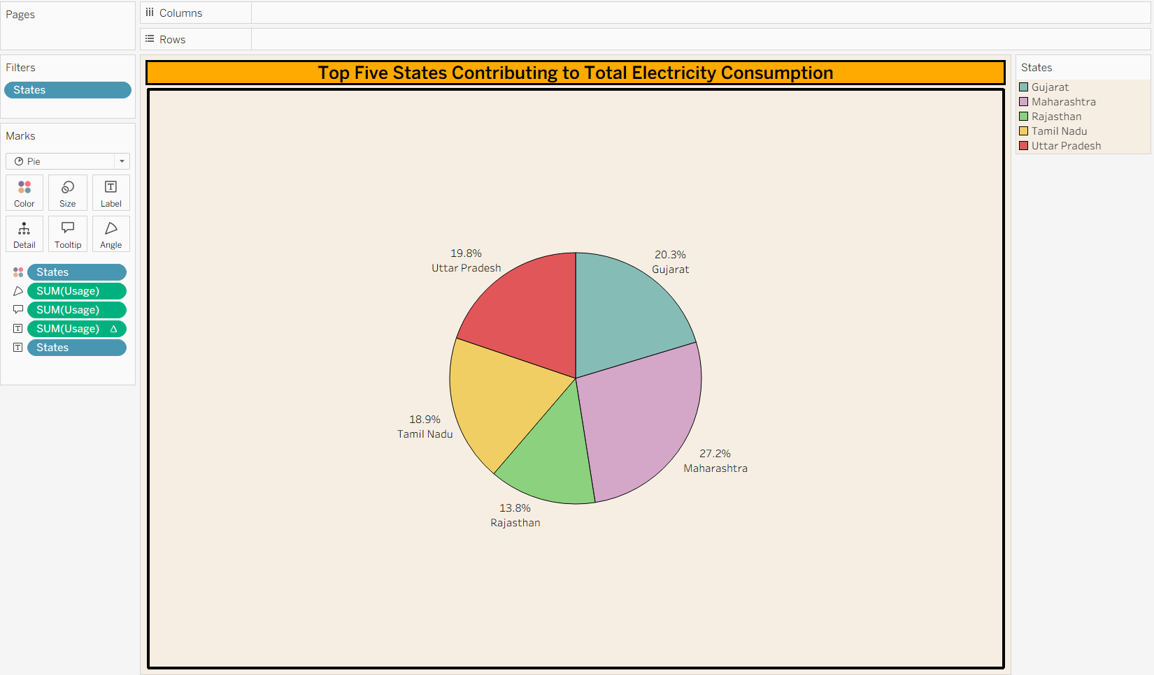

7. How does electricity consumption vary across different seasons (Summer, Monsoon, Winter)?
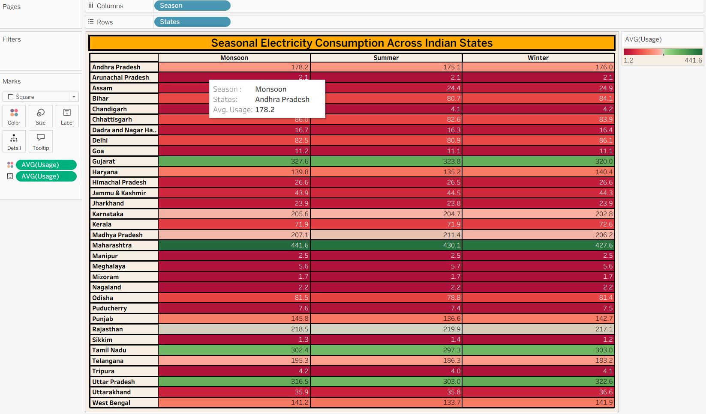
8. Which states showed the strongest recovery from July–December 2020?
